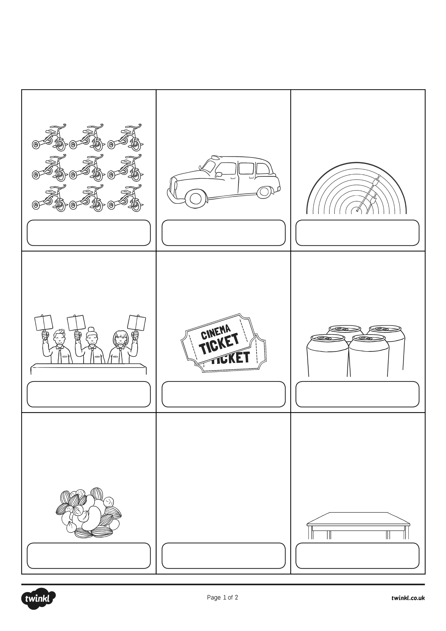
Year 3 Multiplication and Division
Word Problems x3 x4 x8

1. How many wheels would 9 tricycles have?
2. 24 people travel to an airport in taxis. 4 people travel in each taxi. How many taxis are used?
3. Hanan is a keen archer. One day she shoots 5 arrows. Each arrow scores an 8. What is her total score?
4. Three judges award 27 marks overall. They each give the same score. What score did they
each give?
5. Cinema tickets are £8. Six people go to see a film. How much will they pay altogether?
6. Cans of lemonade are sold in packs of 4. Cherie wants 36 cans for a party. How many packs should she buy?
7. Trish, Karen and Layla share equally a packet of nuts. There are 21 nuts in the pack. How many nuts do each get?
8. A machine making mango pieces puts 8 pieces in each snack packet. The machine makes 88 pieces in 1 minute. How many packets are filled every minute?
9. A carpenter makes tables. Some have 3 legs and some have 4 legs. He plans to make 5 tables with 3 legs, and 4 tables with 4 legs. How many legs will he need?

