**Phonics Snakes and Ladders**

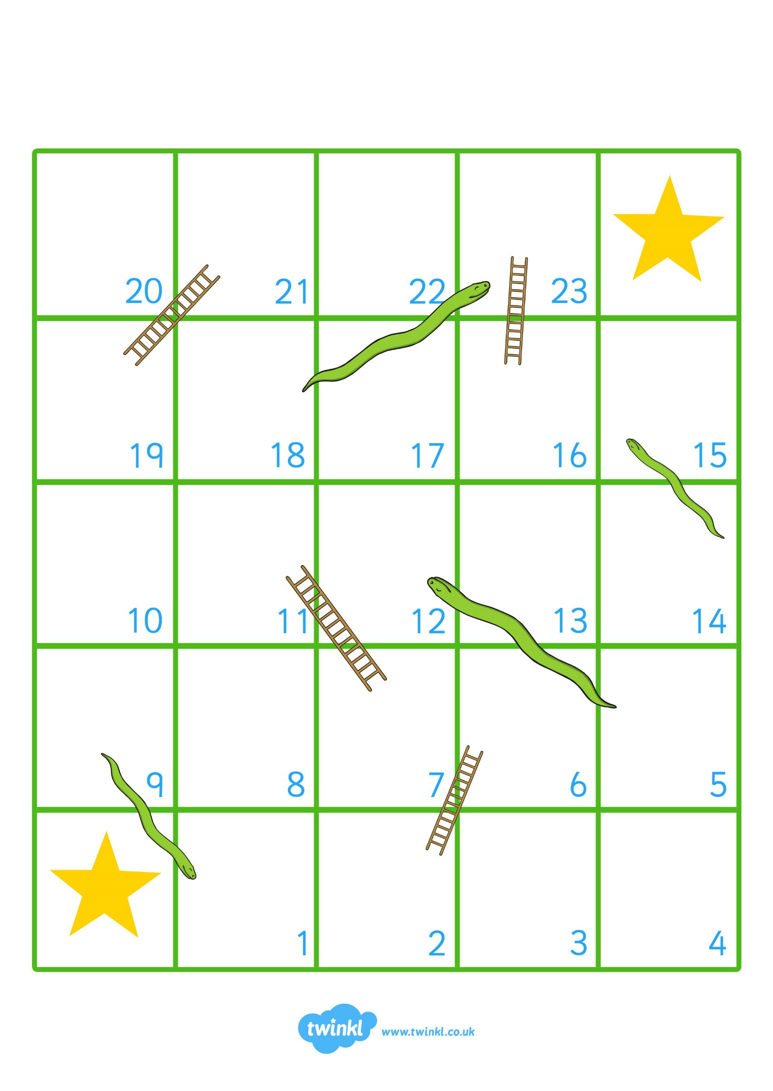

p-o-p

START

s-i-t

d-o-g

p-i-t

d-i-p

s-o-ck

d-i-g

p-i-g

c-o-t

c-a-t

p-i-n

FINISH

t-i-n

p-e-t

r-a-t

s-u-n

n-e-ck

r-u-n

t-a-p

g-a-p

m-u-g

c-u-p

p-a-n

r-u-g

**Counters**

