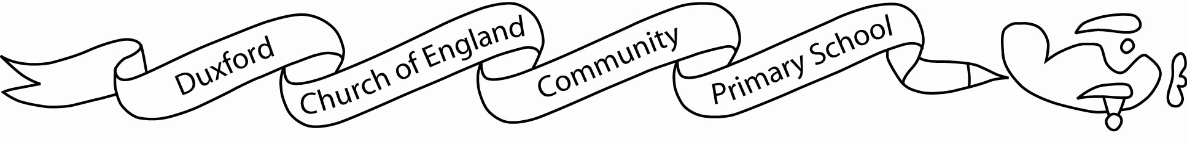

Aim High....Fly High

Dear Parents / Carers 18.04.18
Reception Trip to Fitzwilliam trip
We have an exciting opportunity to attend the Fitzwilliam Museum as part of Miss Batty’s teacher training placement in association with Cambridge University on Thursday 10th May 2018. Cambridge University and the Fitzwilliam Museum are funding the cost of the coach. Reception will have the chance to see many wonderful art pieces and sculptures at the museum, complete sketching and take part in other fun activities with the Museum’s Education Officer and Miss Batty.

We shall be travelling by coach, leaving Duxford at 11:00am and returning to school in time for normal home time arrangements. The children should therefore bring a packed lunch and a drink with them which we will eat when we get to the museum. Please could this be provided in a completely disposable named bag, so all leftovers can be disposed of once the children have eaten. We ask that only throw-away drink bottles be brought, so that the children will not need to carry their water bottle around with them during the day. If your child would like a packed lunch provided by the Catering Service, please let us know by Monday 23rd April 2018.
Please could the children wear uniform and school shoes on the trip.
Please sign the permission slip below and return it to school, by Monday 30th April 2018. If you have any questions, please speak to your class teacher.
Yours sincerely
Miss Kerr, Miss Batty and Miss Nicholson
…………………………………………………………………………………………………………………………………………………………..
Reception/ Key Stage 1 trip to Fitzwilliam Museum

I give permission for my child ……………………………………………………………………………… to visit Fitzwilliam Museum.
My child has the following allergies …………………………………………………………………………………………………….

Signed …………………………………………………………………………………………… Date ……………………………………..

