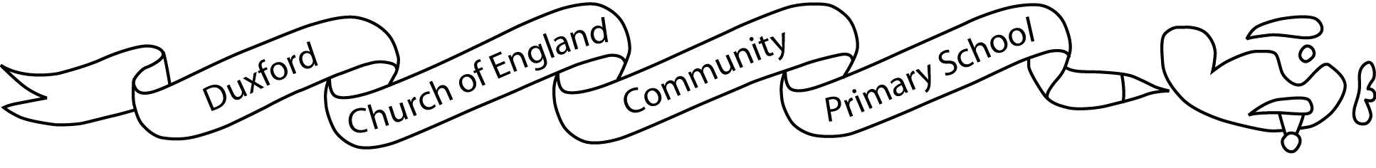

Aim High Fly High
7th January 2019
Dear parents/carers,

Welcome back! We hope you have enjoyed a lovely Christmas break and your child is raring to go in this short and important term.

Our topic this term is ‘Healthy Me, Healthy You, Healthy Us’. Your child will learn about things that positively and negatively affect their physical and mental health. Within this they will be studying light in Science and will consider how light affects mood, with an in-depth geographical study of the midnight sun/ polar night countries. As part of our extra-curricular studies all children will also have the opportunity to participate in a First Aid training course.

There will be an important focus on writing skills this term as we continue to maximise progress before the end-of-year assessments and this is reflected in the choices available for the home-learning tasks.

This term P.E. will remain on Tuesdays and Wednesdays but please ensure that your child has their P.E. kit in school all week and because the weather is still cold, please ensure that your child has adequate kit for outdoor sport as well as for indoor P.E.

Home learning will be given out at the beginning of each half term in the same way as last term – on Fridays. Each chosen piece must be completed to a high standard and returned by Tuesday each week. As well as spellings and tables, children will also continue to be given Guided Reading home learning each week and this must be returned on the day they have their Guided Reading group.

You will be invited to attend a meeting this term, on Wednesday 27th February, which will introduce the Year 6 SATs. You can also keep up-to-date with other important events and updates via the school website and the Airwaves newsletter. We will also be running our very first Maths Café, which will give you the opportunity to come in and learn from the children how they work on tasks in Maths. The date for this is Wednesday 13th February.

If you have any questions, concerns or if you can offer any time to support learning, please either pop in at the end of a school day (before school is an extremely busy and important preparation time) or make an appointment to see one of us via the school office.

Yours sincerely,

Miss Medley and Mrs Johnston

