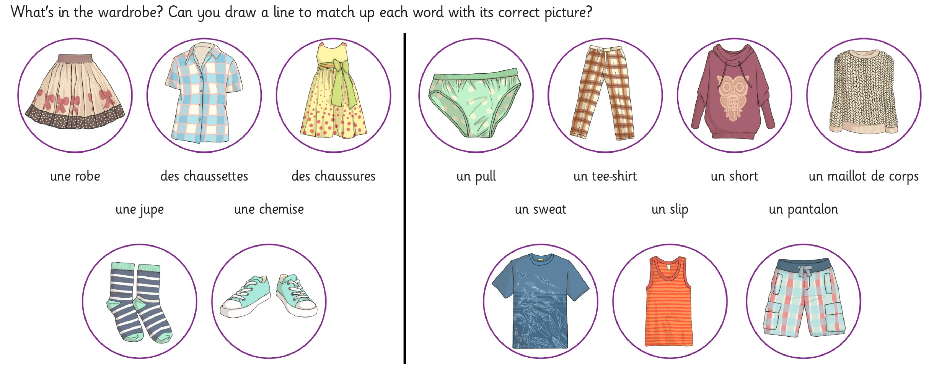
Challenge A

Now draw a picture of your family and label the clothes they’re wearing.

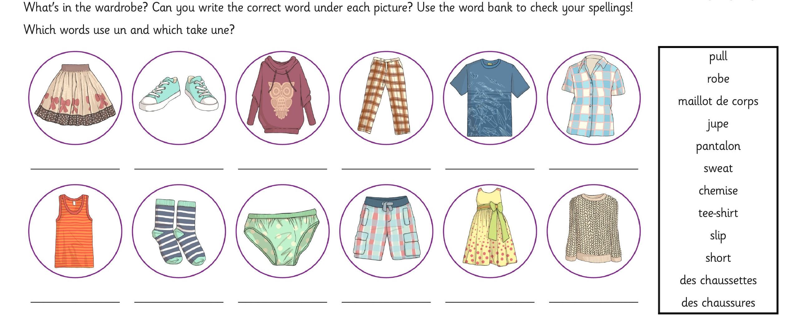
Challenge B

Now draw a picture of your family and label the clothes they’re wearing.

