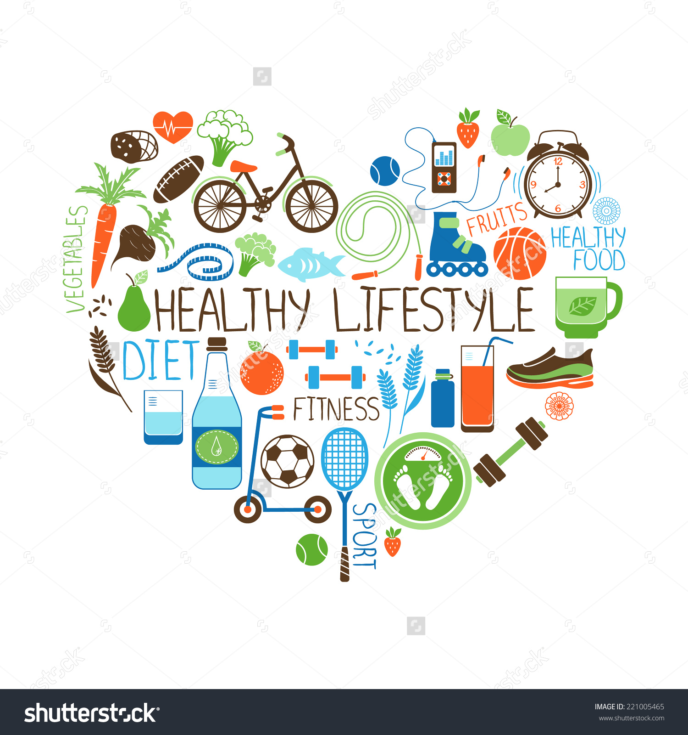
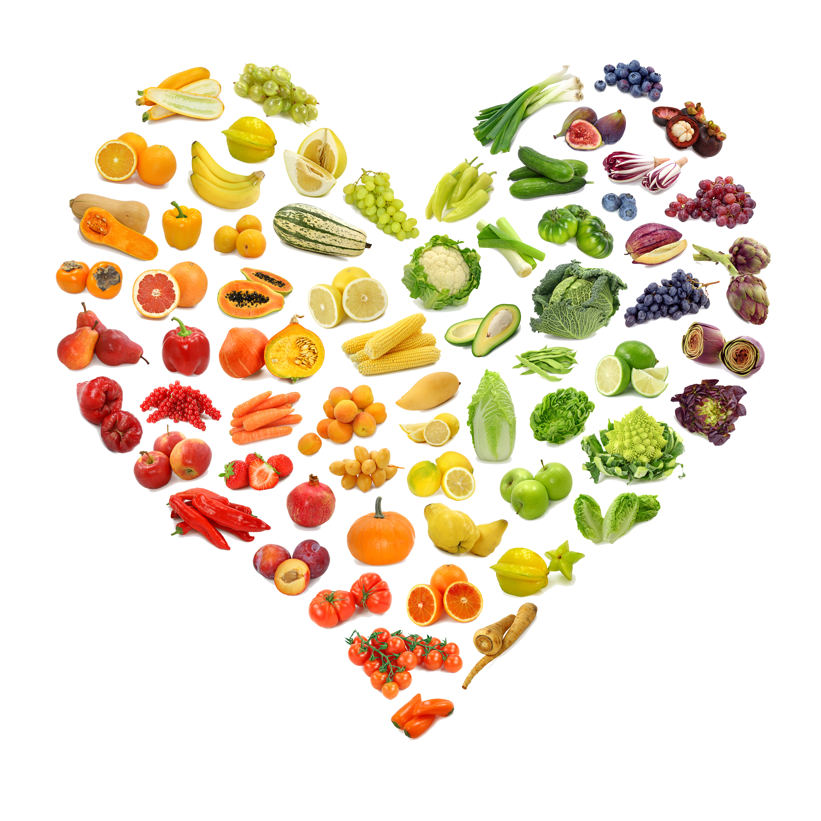
Lower key Stage 2 Spring 2019
Healthy me, healthy you, healthy us!
MAIN SUBJECT FOCUS: Geography
Length: Spring Term 2019
Subject focus: Music
Lessons will be focused around one song: Three Little Birds. Games, elements of music (pulse, rhythm, pitch etc.), singing and playing instruments will all be linked.
Also children will explore a range of composers through Classical 100 in celebration assemblies.
singing and playing instruments are all linked. As well as learning to sing, play, improvise and compose with this song, children will listen and appraise other reggae songs.

Subject focus: PE
Netball and Tennis will be taught by teachers. Orienteering and basketball will be led by a Cambridge United coach.

English:
The genres of writing will include:
- Recounts
- Instructions
- Persuasive writing
- Letters

Subject focus: Art/DT
Designing and creating a healthy meal with its own packaging, sketching, painting, collages and more.
Subject focus: Geography and History
Investigating where healthy food comes from around the world. Where are fruit and vegetables grown? Why are they grown there?

Why is recycling part of a healthy life style for us and the animals in our world?

Maths:
In accordance with the National Curriculum and the White Rose Maths scheme of learning, Year 3 will cover multiplication and division, money, statistics, length and perimeter and fractions. Year 4 will cover multiplication and division, area, fractions and decimals.
Please concentrate on learning times tables in this order x2, x5, x10, x4, x8, x3, x6, x9, x7, x11, learn the division facts as well as the multiplication facts.
In addition discrete learning:
Guided reading
Spelling
Times tables
Handwriting
French
R.E.
Computing
Grammar

Subject focus: Science
Animals and Humans
What is nutrition and why is it important? Where does it come from?
The human and animal digestive system will be explored, as well as their skeletons and teeth.

