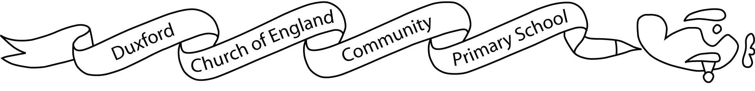

Aim High, Fly High
Dear parents/carers,

I hope you have enjoyed the summer break and are all well. I am pleased to welcome your child and family to Year 3. My key focus initially will be settling the children, addressing any anxieties and focusing on positive learning behaviours. I am confident the class will thrive on being back together at school.

Once we are settled, we will have a very busy term ahead of us. Our main learning focus will be our topics ‘The Iron Age’ in the first half term and ‘The Romans’ in the second half term. In these topics we will study who these important groups of people were, their place in history, aspects of their culture and their impact upon this country today. In addition, this term’s science topics will be: Light and Forces and Magnets. More information about the learning we will be doing can be found on the accompanying curriculum grid

This term P.E. will be on Mondays and Tuesdays every week. Please ensure that your child has appropriate P.E. kit for the weather (plain white T-shirt, shorts or jogging trousers, sweatshirt and suitable trainers for outside activities). Please also be aware that, for health and safety reasons, earrings must be removed for P.E. Children will not change for PE sessions in school and so will continue to wear kit to school on PE days. Children will also run the daily mile each day and will have an outdoor learning session every week.

Children are welcome to bring in a healthy fruit or vegetable snack during morning playtime. We ask children to bring a named bottle of water to drink during the day which will be returned for washing every evening. To carry these items, children may bring a small bag to school each day. The children must be able to hang this small bag with their coat on the back of their chair inside the classroom. If children choose a packed lunch they should bring that too. Lunches will now return to being eaten in the hall every day.

Home learning in Year 3 is a mixture of compulsory and optional activities. Each week, children will be expected to use Times Tables Rockstars and Spelling Shed to practise key skills in these areas and they will be assessed on their progress in spelling each Monday. Passwords for Starz, Rockstars and Spelling Shed will issued in due course.

Your child should also continue to read regularly at home and complete a weekly challenge from our Guided Reading learning challenge grid. The grid can be found as an attachment to this email and activities should be completed in home learning books.

In addition, a grid of home learning activities will be provided. In Year 3, this grid home learning is optional and children are encouraged to choose the activities they would like to complete. The activities are a mixture of English and Maths tasks alongside topic-based learning. These tasks should also be sent back completed in home learning books please.

If you would like to discuss any aspect of your child’s time in Blackbirds please do make an appointment via the school office. These meetings can be on the phone, virtually or in person. Quick notices can be passed to me via the school office or by leaving a message with the member of staff on gate duty. Please note that our class email addresses are no longer in use and all emails should be addressed for the school office.

I look forward to working with you and your child and to an exciting year ahead.

Best wishes,

Sam Butler
Blackbirds’ class teacher

