Literacy
Reading
-Reading a wide range of stories about starting school and making friends
-Reading fiction and non-fiction dinosaur books.
-Maintaining attention while sit quietly, listening to others, during appropriate activities.
-Phonics sessions covering phase 2 sounds and tricky words (more information on this during the phonics parents workshop on the 29th September).
Understanding
-Following simple instructions.
-Talking about the main events in a story.
-Making predictions about what they think will happen next in a story.
-Talking about the main characters in a story.
Speaking
-Taking turns when in a group or whole class session to talk. Thinking about what others have said before responding.
-Sharing their ideas to questions with their talk partner during whole class or group session.
Personal, Social and Emotional Development
-Learning names and making new friends in Buttercup class.
-Developing the confidence to speak in front of a small group.
-Talking about their favourite things and interests and comparing these with their new friends when showing their ‘me boxes’.
-Developing confidence to initiate play or games.
-Agreeing class rules and following them
-Identifying their own and others feelings.
-Caring for their belongings.
-Developing confidence to ask for help.
-Learning to always have a go.
-Meeting the learning animals and talking about how we learn.

Mathematics
Number
-Counting forwards and backwards, to and from 0-20.
-Counting reliably up to 10 then 20 objects.
-Reading and writing numbers to 10.
-Singing number songs to aid number recognition.
-Number hunts.
-Dice and domino games.
-One more/one less.
-Number problems.
-Ten Town and Number blocks.
Shape, Space and Measure
-Recalling events from the summer in the right order.
-Learning the class routines and ordering the school day e.g. breakfast, break time, lunch, PE etc.
-Patterns, pictures and models.
- Shape hunts.
-Ordering people’s height (short/tall).
-Measuring the dinosaur footprints.
-Weighing ingredients when cooking and comparing eggs
-Positional vocabulary.

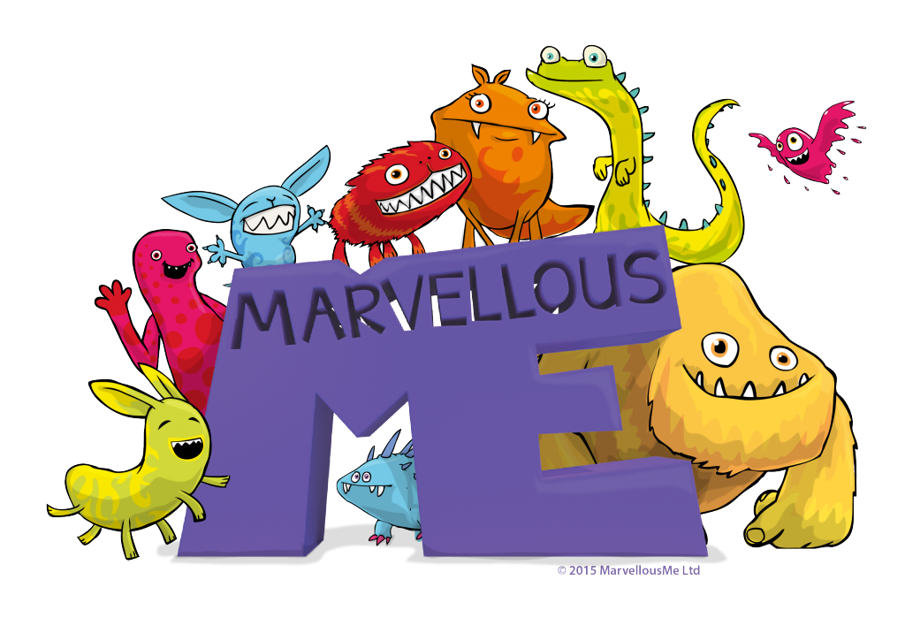
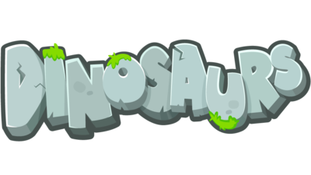

Buttercup class
Autumn 1

Physical Development
Moving and Handling
-Developing spacial awareness and control.
-Developing throwing and catching skills.
-Daily movement for learning programme.
-Squiggle while you wiggle PE mark making.
-Play dough disco
-Crossing the midline activities.
-Developing scissor skills.
Handwriting
-Introduction to cursive letter formation
-Writing their name and forming numerals.
Health and self care
-Managing their own basic hygiene. Going to the toilet independently.
-Putting on and removing clothes, costumes and outdoor all weather suit independently.
Expressive Arts and Design
-Drawing our portraits and thinking about the features of our face.
-Learning and singing a variety of songs linked to the topic and harvest.
-Large scale painting and printing.
-Dot day special art activities.
-Learning about the artists Kandinsky and Seurat.
-Making dinosaurs out of clay.
-Collaging dinosaurs and creating watercolour dinosaur paintings.
-Creating dinosaur silhouettes.
-Creating dinosaurs and dinosaur fossils out of clay and salt dough.
Role plays-Home corner, shop, dinosaur museum, dinosaur excavation site.
Knowledge and Understanding the World
-Finding out where we went on holiday as well as where Buttercup the class cow travelled to.
-Thinking about our families and how they are unique and special.
-Finding out facts about eggs and animals that lay eggs.
-Comparing the appearance of different kinds of eggs.
-Learning about different kinds of dinosaurs.
-Learning the difference between a carnivore and a herbivore.
-Learning about palaeontologist and what fossils are.
-Doing a fossil dig.
-Learning about how we can stay strong like dinosaurs.
-Learning about dinosaur environments.
-Learning about different kinds of materials and their properties.

