AIM HIGH.....FLY HIGH

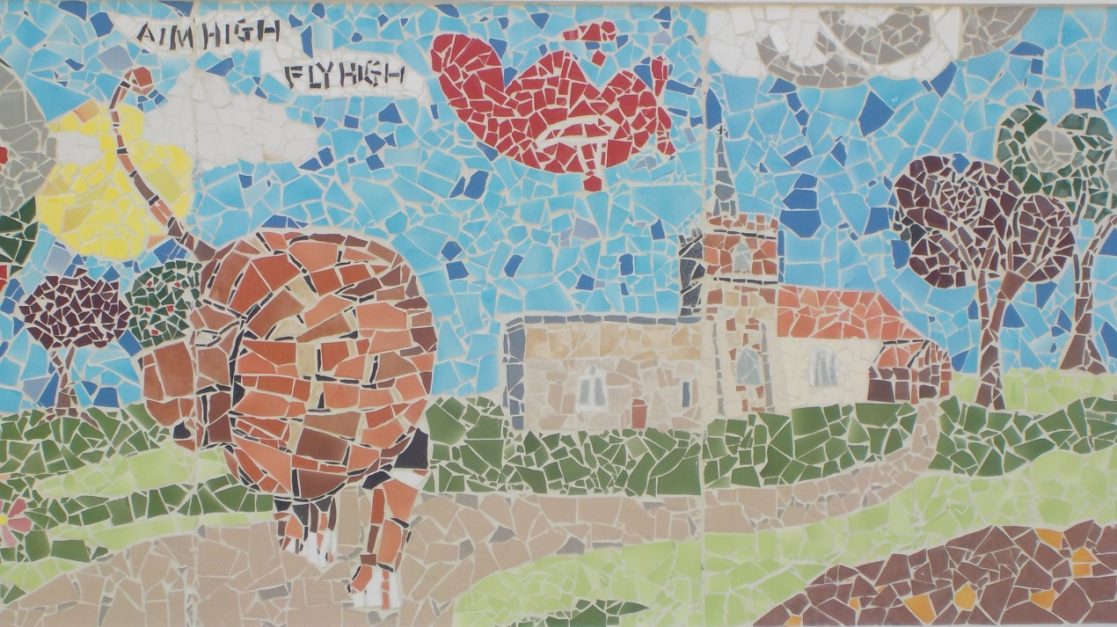

PARENT HANDBOOK

Produced by Duxford Church of England Community Primary School

Issue 14, 2017

Contents Page

Aims and Values 3

Welcome to Duxford Primary School 4
Welcome to Reception 9
Enjoying books at home and at school 12
Assemblies 13
School Clothing and Property 14
DX Breakfast and After School Clubs 16
Extra curricular activities during the school year 17
Clubs and Sports 17

Instrument Tuition 18
Music Workshop 18
Child Welfare 19
The National Curriculum 22
Staff List 25
The FODs 26
The Governing Body 26
Education Jargon Buster 27
Further Information 28

Aims and Values of Duxford (C of E) Community Primary School

Aims

We aim to nurture happy, healthy children within our safe and spacious school environment.

We aim to enable and encourage every child to fulfil his or her unique potential in every aspect of school life. We believe that children with different abilities, backgrounds and talents have much to contribute to each other.

We aim for academic excellence and for each child to leave with a lifelong love of learning.

We aim to allow space for spiritual awareness and growth in a broadly Christian context.

We aim to provide a rich and varied curriculum where children are confident and creative independent thinkers who can work collaboratively.

We aim to develop resilience and perseverance in our children in order that they can respond flexibly to the rapid changing society in which we live.

Values

Self
We value ourselves as unique human beings, approaching each day with a sense of wonder and curiosity.

Relationships
We value relationships as fundamental to the development and fulfilment of ourselves and others. Our good relationships include: consideration, honesty, respectfulness, fairness and forgiveness.

Society
We value truth, inclusiveness and diversity; justice and human rights. We value the families within our whole school and our place within the wider community.

The Environment
We value the environment, both natural and shaped by humanity as the basis of life and a source of wonder and inspiration.
WELCOME TO DUXFORD SCHOOL!
There is a huge amount of information to take in when your child starts a new school, particularly if this is your eldest child and their first experience of school. This might be the first time that you have been back to a primary school since leaving your own! You will find that lots of things have changed and we hope this booklet will go some way towards explaining some of these changes. This guide is produced to answer some commonly asked questions that may not have been answered in the school’s official documentation, to talk about school routines and give practical guidance.
We hope your child flourishes and enjoys their time at Duxford School.

GENERAL LIFE AT DUXFORD SCHOOL

When does school start and finish?
The school day starts at 8.55am. A whistle is blown at 8.50am and children are then allowed into school. Lunchtime is from 12.00noon to 1.00pm. All children have a 15 minute break in the morning and Reception and Key Stage 1 pupils have a 15 minute break during the afternoon. Reception and Key Stage 1 children finish at 3.20pm and Key Stage 2 children finish at 3.25pm. An on-site breakfast club is available from 7.45am and an after-school club is available until 6pm. More details are available through the school office.

What are school dinners like?
Meals are provided by our own catering team Cambridgeshire Catering Services (CCS) and prepared in the school kitchen. A menu is published each half-term, which is sent out to families and displayed at the main entrance. It is also available via www.myschoollunch.co.uk/cambridgeshire. The lunch provided consists of a hot two-course meal, offering a choice of main courses, vegetables, salads and dessert or a light bite option. The menus are designed to be tempting and healthy and offer choice for vegetarians with some special diets available. CCS endeavours to purchase local, sustainable food from within the East Anglian Region ensuring their safety, standards, quality, environmental protection and animal welfare are upheld.

From September 2014 the Government have stated that all children in Reception and Key Stage 1 will be entitled to a free lunch. Children can still choose to bring in a healthy packed lunch.

How do I pay for cooked lunches?
School lunches are currently £2.30 per day for Key Stage 2 children, and must be paid for in advance. Payment is made via ParentPay, a secure, online way of paying for school lunches with a debit/credit card. Alternative arrangements can be made if this is a problem, please speak to the School Office.

What happens at lunchtime?

Parents/carers can choose if children have a cooked lunch and on which days. Children choose between two main courses (including a vegetarian option) or the light bite option each day and a coloured wristband system makes sure they are given the right meal by the catering staff. The youngest children are served first so they don’t need to wait for their lunch and the children sit in friendship groups. If your child has a packed lunch please try to make sure they can manage their food themselves and can open any packaging you give them. Please provide a teaspoon if necessary and do not include fizzy drinks or sweets.

Lunchtimes are staffed by Teaching Assistants who will keep an eye on the children especially in the early months of Reception but it does help if children can be as independent as possible. Children are encouraged to eat/try their entire main course before starting their dessert, and are praised with awards stickers.

If you have particular concerns about your child’s eating please contact your child's class teacher.
When children have finished eating, they go outside to play on the playground. They are supervised at all times by Teaching Assistants. Year 6 children have the opportunity to play with the younger children on a rota basis. They also take part in a Play Leader course to help them in their personal development.

What about snacks for break time?
The school takes part in the Government’s ‘School Fruit and Vegetable Scheme’. Under this scheme all Reception and Key Stage 1 children are provided with a fruit or vegetable snack free of charge for the mid morning break. Key Stage 2 children may bring in a healthy snack in addition to any packed lunch. Ideally this should be a piece of fruit or vegetable. It should not be crisps, chocolate or biscuits.

What should I do if my child is not well enough to come to school?
If your child is too unwell to attend school, please contact the school office before 9am each day that they are absent. If you have not contacted the school office and your child is absent, the school office will contact the parent/carer to establish that your child is safe.

What if I want to take my child out of school for a holiday. Is this possible?
The school is very proud of the good record it has for attendance. The Department of Education states that authorised absence will only be granted for exceptional circumstances. Forms to apply for absence due to exceptional circumstances can be obtained from the school office. Please see the Attendance Policy on our website.

I don't live in Duxford. Is there school transport available?
Free transport is available to children living in Hinxton, Ickleton and Heathfield. Each child is issued with a pass for the year. Transport application forms are available from the school office or via www.cambridgeshire.gov.uk/education/transport. Please let us know in advance if there are any changes to your child’s routine. If you are expecting your child's friends to travel home with them for tea, you will need to contact the office who may be able to will issue a temporary pass.

What happens to children who use the school buses?
In the morning children are collected from their designated bus stops. The buses park by the Key Stage 2 entrance so the children are delivered straight into the school grounds. A bus register is kept by the school office and all children are escorted out to the buses in the afternoon. There is also an escort on the Hinxton/Ickleton bus who ensures that seat belts are done up. We publish a code of conduct for school bus travel which can be viewed on the County Council website (see above) or from the school office.

What happens if I am unable to pick up my child from school at the end of the day?
Always contact the school office by phone or email, or have a note dropped into school so that we know what alternative arrangements you have made. If we don’t hear from you we will hold your child back until we have found out what the situation is (see section on Child Welfare). We will always use a common sense approach whilst taking the safety of the child first and foremost.

When can I see the teacher?
You do not have to wait for the formal ‘parents evening’ to see your child’s teacher. The best time to speak to the teachers is usually at the end of the school day. If this is not convenient or you have a particular matter you wish to discuss in private it may be preferable to make an appointment.

What if I have a question about school?
Questions specific to your child's class should be raised with the class teacher. Teachers are happy to answer questions and queries at the end of the school day, or if you feel you may need more time, please call the
office to arrange a meeting at a suitable time. General questions about school life can be taken to the school office staff who are always happy to help, or you can arrange a meeting with the headteacher.

How do I pass my comments, concerns or complaints to the school?
If you have a concern or a complaint about something please take it to the class teacher. In most cases this will resolve any concerns. However, should you need to discuss the concern further, you can arrange a meeting with the Key Stage leader, deputy headteacher or headteacher. The school would always rather know of problems early on so they can work together with parents/carers to resolve them.

Please remember that teachers are human like you, and they too like to be thanked and encouraged. Do let them know if something has gone well. A word of appreciation for some special project or a note of thanks can mean a great deal!

What is the home school agreement?
This is a document that sets out the responsibilities and expectations of the school, parents and children. Each of the parties is expected to read and sign up to their individual elements. We believe that the Home–School partnership is an essential part of our commitment to success. We see teachers and parents as equal partners working together to enable all children to reach their potential. We hope you will take an active part in your child’s education and we welcome the help of parents/carers and grandparents in school.

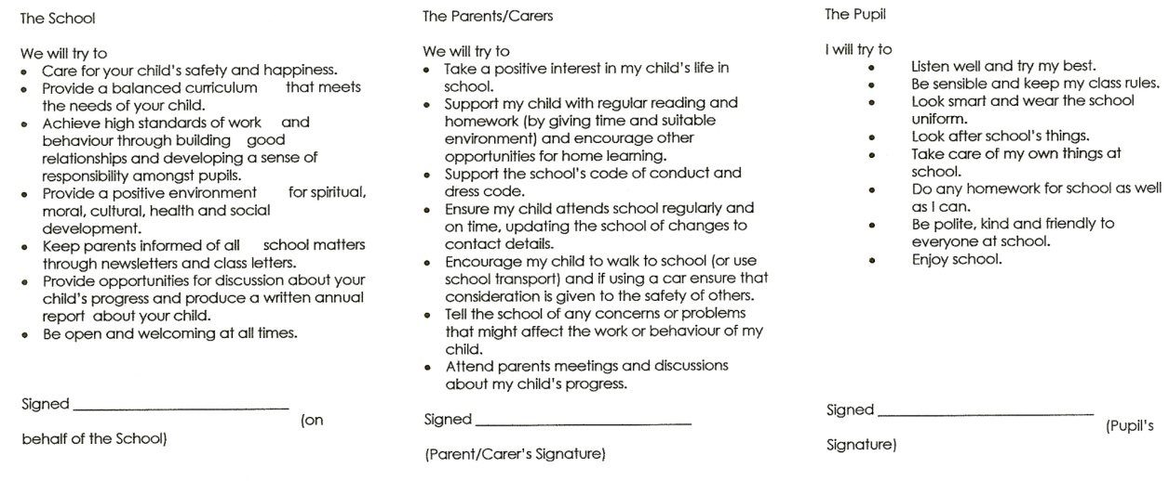

I’d like to come and help in school but how do I to go about it?
Parents currently help in all sorts of ways. These include: helping with craft activities, listening to children read, joining class trips, washing fruit, making displays of children’s work, jointly running a lunchtime club and as a general helper in the classroom. Some people have particular skills or areas of expertise such as gardening, music or computer skills, and get involved in particular projects. Help is needed all through the school and some people prefer to help in a different class to their child. All help is very gratefully received and much appreciated.
On the rare occasion a parent is asked to help one to one with a child, a DBS (Disclosure and Barring Service) check would be required.

WELCOME TO RECEPTION

The curriculum in our Reception Class follows the new amended Statutory Framework for the Early Years Foundation Stage as determined by the Department for Education in September 2012. Within this Framework, the characteristics of effective learning for the children in the Early Years are defined as:

- Playing and exploring – engagement ( finding out and exploring, playing with what they know, being willing to ‘have a go’)
- Active learning – motivation ( being involved & concentrating, persevering, enjoying achieving what they set out to do )
- Creating & thinking critically – thinking ( having their own ideas, making links, choosing ways to do things )

We believe that learning in the Early Years is a crucial foundation for all later education and is in itself an essential stage in each child’s development. The Under-6 curriculum is planned to achieve readiness for statutory schooling in seven areas of learning.

The seven areas of learning are split into prime and specific areas, as follows:

- Prime areas of learning and development are fundamental, work together and are moved through to support development in all other areas. These prime areas are :

  - Personal, Social and Emotional Development involves helping children to develop a positive sense of themselves, and others; to form positive relationships and develop respect for others; to develop social skills and learn how to manage their feelings; to understand appropriate behaviour in groups; and to have confidence in their own abilities.

  - Communication and Language involves giving children opportunities to experience a rich language environment; to develop their confidence and skills in expressing themselves; and to speak and listen in a range of situations.
  - Physical Development involves providing opportunities for young children to be active and interactive; and to develop their co-ordination, control, and movement. Children must
also be helped to understand the importance of physical
activity, and to make healthy choices in relation to food.

- Specific areas of learning include essential skills and knowledge for children to participate successfully in society and are :

  - Literacy development involves encouraging children to link sounds and letters and to begin to read and write. Children must be given access to a wide range of reading materials (books, poems, and other written materials) to ignite their interest.
  - Mathematics involves providing children with opportunities to develop and improve their skills in counting, understanding and using numbers, calculating simple addition and subtraction problems; and to describe shapes, spaces, and measures.
  - Understanding the World involves guiding children to make sense of their physical world and their community through opportunities to explore, observe and find out about people, places, technology and the environment.
  - Expressive Arts and Design involves enabling children to explore and play with a wide range of media and materials, as well as providing opportunities and encouragement for sharing their thoughts, ideas and feelings through a variety of activities in art, music, movement, dance, role-play, and design and technology.

Active Learning through Play
‘Play is the work of the child’
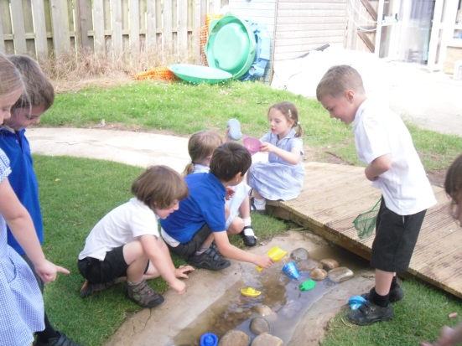
At Duxford we understand the importance of play and the motivational force this has on a child’s learning process. Active Learning is the natural way children learn about their environment and develop their own capabilities. It enables them to exercise their imagination and extend their physical abilities, try out new ideas and problem solve. Through active learning children develop social relationships, language, a sense of achievement and increased self-esteem.
The social play areas within the reception classroom are often linked to the topic for the term and have become castles, shops, post offices, garden centres and hospitals.

Buddies

In order that our Reception children feel secure when they join Duxford Primary School, they are allocated a Year 6 ‘buddy’. Thus they immediately have a friendly, helpful and sympathetic face showing them where everything and everybody lives and guiding them through the break and lunch periods. Children also become members of a House Group – Lancasters, Spitfires, Hurricanes or Concordes. The children take part in a lot of activities throughout the year in their House Groups.

What is 'Show and Tell’?
The class will usually have a weekly theme that they are focusing on. Giving the children the opportunity to bring in something related to that topic and say something about it helps to reinforce learning and give them confidence speaking in front of the class.
The children also take part in Circle Time where they discuss about keeping safe and healthy. Apart from this, children are not encouraged to
bring toys and other personal possessions to school and anything valuable is best given to the teacher for safe keeping.

ENJOYING BOOKS AT HOME AND AT SCHOOL

Can you explain the scheme for reading books in Key Stage 1?
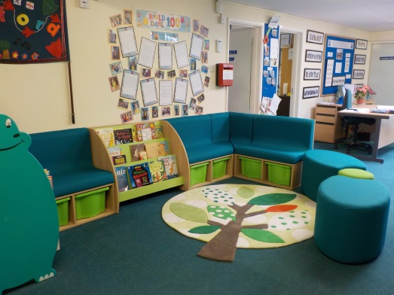
We are very proud of our fabulous new library and encourage children to choose and take library books home to share from when they start school. You are welcome to come and help them choose a book at the end of the school day. In the first few weeks your child’s reading ability will be assessed and when appropriate they will be given a reading book to bring home. After the children have settled in, you will be invited to a reading meeting where the method used to teach reading is explained, including how best to support your child.

What are the coloured dots on the books for in Key Stage 1?
The different colours are simply a way of grading the books from different reading schemes. There will probably be some degree of overlap but the books get more difficult in terms of the number of words on the page, the complexity of the vocabulary, length of sentences etc. The teacher will assess when a child can start to choose books from the next colour box.

How is reading taught in Key Stage 2?
At Key Stage 2 (year 3 to year 6) the children read in groups on a weekly basis. This is known as guided reading. A text is selected and a piece of homework is set related to that particular book. The children have reading journals where they will answer the questions and return it to school on their reading day. In addition children read books from our libraries. We would encourage you as parents/carers to support your child to read, listen to audio books. Remember the more your child reads or listens to stories, the better a writer they will become!

ASSEMBLIES

The children attend a daily act of collective worship, or assembly. These follow a regular pattern

Monday A celebration assembly at which special cards are presented, house point results are announced and any achievements of individuals or teams are celebrated. Every child who has had a birthday is invited to share and ‘Happy Birthday’ is sung. These assemblies usually take place at 9.05am and parents are welcome to attend.

Tuesday The local rector leads the assembly following the themes of the Christian year.

Wednesday The Key Stages have separate assemblies led by their teachers at which relevant issues are addressed and hymn singing is practised.

Thursday In the Autumn and Summer terms each class leads an open assembly where children share their class and project work. Parents and grandparents are invited to attend this special assembly.

Friday This assembly is led by various members of the local Christian churches following a termly theme.

Assemblies are broadly Christian, also including stories and reflections from other cultures and religions. Throughout the year there are special celebrations for Harvest Festival, Christmas, Mothers Day and other festivals. The last assembly of the year is very special. It is led by the Year 6 leavers and celebrates their time at Duxford.

Parents may withdraw their children from collective worship
and/or Religious Education lessons.If you choose to do so please send
a written request to the Headteacher.

SCHOOL CLOTHING AND PROPERTY

The school feels that it is important that the children look smart and feel part of a team. This all contributes to the ethos of the school and helps set an appropriate tone. For full details see our Uniform Policy on our website.

Uniform
The following items, with the school logo, are available through the school office.

White or Blue Polo Shirt
Blue Sweatshirt or Cardigan
Sun Hats
Book Bags
Year 6 only
Maroon Sweatshirt or Cardigan

Grey/black trousers, skirts or pinafores can be bought from most retailers. In summer shorts and gingham dresses are acceptable (no leggings underneath skirts or dresses please). In the winter (again no leggings) thick tights can be worn under skirts or pinafores. Tights should be either, white, grey, black or navy blue.
Children should wear appropriate shoes (no trainers please) to school which are safe for class and playtime activities.

In the interests of safety only one pair of small stud earrings may be worn in school. These must be removed by the child before PE activities in order to comply with health and safety regulations. If your child is unable to do so please remove them before school. Long hair should be tied back at all times, not just for PE in the interests of safety. No make up including nail varnish is to be worn.

Painting Overall
All children will need suitable clothing for painting (an adult’s old shirt etc.).

PE and Games Kit
Each child is required to have plimsolls, shorts (navy or black), and a t-shirt (preferably royal blue, white or a plain colour applicable to their house group). Children will need suitable clothing for outside games including a change of trainers or plimsolls, and in cold weather, tracksuit bottoms and a sweatshirt. This equipment should be put in a named PE bag which will then be kept in school P.E kits are sent home at the end of every half term so that they can be washed and checked for size!.
All items must be named!

Lost Property

Please clearly mark all clothing with the name of your child so that it can be returned when lost.

In Key-Stage 1 all items of lost property are kept in the classrooms. In Key-Stage 2 it is collected in a plastic bin at the end of the Key-Stage 2 corridor.

Children’s Personal Property
Valuable items such as jewellery and precious toys, including electronic games and mobile phones should not be brought to school because school cannot accept responsibility for any damage to or the loss of children’s property.

THE DX CLUB
BREAKFAST AND AFTER-SCHOOL CLUBS

Duxford Primary School has a hugely successful before and after school club called The DX Club. The DX Club is a managed by a voluntary committee of parents of children who attend Duxford Primary School. The DX Club is registered charity and is also registered with Ofsted and in their last inspection received an overall Good rating.

Working parents can take advantage of a safe environment where children can be dropped off and have breakfast before-school. The Breakfast Club is open from 7.45am and is held in the Community Room in the foyer of the school. The cost is currently £5.25.
You may also arrange afterschool care for your child until 6pm. It is held in the Sunshine Room at the Key Stage 1 end of the school. The cost is currently £7.35 per session until 4.30pm, or £11.70 until 6pm. Sibling discount for a full session is £10.10. Children staying until 6pm are provided with a cooked tea.
The school office has further details and registration forms.

HOLIDAY CLUB
The DX Club have also recently registered to provide a Holiday Club and this is held at Hinxton Village Hall. The Holiday Club is open daily between 8am and 6pm during most school holidays and also professional days.

EXTRA CURRICULAR ACTIVITIES DURING THE SCHOOL YEAR
Clubs and Sport
Duxford School offers a great choice of lunchtime and after school clubs for your child to enjoy at different times throughout the year. Some of them are offered to particular year groups:

Eco Club Choir Homework Club
Gymnastics Tennis Basketball
Library Chess Cricket
Football Clubs Stage Dance Multi-sports
Netball Cross-Country Choir
Athletics Orchestra

The outdoor Multi-Sports Court is well used. Local sports initiatives, teachers, the school’s coaches and parent volunteers have enabled
children to enjoy basketball, football, netball, tennis, cross-country, athletics and gymnastics as clubs and after-school activities.
See our website for up to date information on school clubs.

In addition to the weekly scheduled activities, below are listed some examples of other key events that happen during the school year.

January | School Disco
February | Parent/teacher consultations
March | World Book Day, Science Week, Years 3,4,5 performance
May | Walk to School Week,  Family Residential Evening
June | Safer Cycling Scheme, School Fete, Outings for Years Reception to 4 Trip,Year 6 Residential Trip
July | Open Evening, Leavers’ performance, Leavers’ assembly, whole school trip to the seaside
September | Harvest Festival, New Class Information Evening
October | Ely Cathedral Day, Parent/teacher consultations
November | Art Festival, Maths Week
December | Christmas Fayre, Christmas Dinner, Nativity Play, Choir service in church

Instrument Tuition

The school works in collaboration with Cambridgeshire County Council to provide music tuition on site to students through Cambridgeshire Music.

Tuition is available (depending on demand) for:

Recorder, Flute, Clarinet, Oboe, Bassoon
Trumpet, Cornet, Trombone, Tenor Horn, French Horn, Baritone, Tuba
Violin, Viola, Cello, Double Bass
Percussion, Drum Kit
Piano, Keyboard
Guitar, Bass Guitar
Voice

The school provides full instruction on how your child can participate at the relevant time. More information can be found at:

www.cambridgeshiremusic.org

Music Workshop

Duxford Primary School is fortunate to have close links with Duxford Saturday Workshop (a music and drama workshop offering many different musical opportunities). This is a fantastic group which is open to all adults and children from the age of five years. Should you wish to find out more detail, the workshop has a very informative website at:

www.duxfordsaturdayworkshop.org.uk

Annual registration for the workshop occurs on a Saturday in September. The process for joining is to go along to the workshop to discuss your musical or dramatic area of interest. You will be asked to fill out a registration form which can be found on the website.
The Workshop is fortunate to have a good stock of musical instruments for members to borrow for a small fee. Whilst membership is open throughout the year, those joining after the September registration day may be limited in choice.

CHILD WELFARE

Child Protection
It may be helpful to parents to know that the Authority requires Headteachers to report any obvious or suspected case of child abuse - which includes non-accidental injury, severe physical neglect, emotional abuse and/or sexual abuse. This procedure is intended to protect children at risk and schools are encouraged to take the attitude that where there are grounds for suspicion it is better to be safe than sorry. This does mean that Headteachers risk upsetting some parents by reporting a case which, on investigation, proves unfounded. In such circumstances, it is hoped that parents, appreciating how difficult it is for Headteachers to carry out this delicate responsibility, would accept that the Headteacher was acting in what were believed to be the child’s best interests.

Medicines in School
We are able to administer routine medicines such as antibiotics. Please complete a Medicine Form, available from the school office, if medicine needs to be administered during school time. Inhalers should be kept in the classroom and if possible stay in school at all times.

Parents of a child with asthma or a chronic condition should contact the school to discuss the individual needs of the child.

Illness
If your child becomes unwell during the school day they will be cared for by a trained first-aider and parents/carers will be contacted and asked to collect their child.

If a child becomes unwell with vomiting or diarrhoea please allow 48 hours to elapse after the symptoms have ceased before returning them to school.

Accidents in School
In the event of an accident, we will act in the manner of a responsible parent. All our teaching assistants are qualified in first aid and in the event of an accident, they will provide the child with appropriate treatment. The school will assess if the parent/carer needs to be called and, in the unusual event of a serious injury, whether an ambulance needs to be called. Every effort will be made to contact the child’s parents or guardians. If we are unable to do so we will contact the child’s personal doctor and in the event of an emergency the child will be taken straight to Addenbrookes Hospital.

Appointments
All dental, doctor and hospital appointments should be made outside of school hours and not in term time. However, if your child has to leave school during lesson time for any reason (e.g. to attend a dental or hospital appointment) please would you put the request in writing and collect your child from the office. We will also require proof of the appointment in the form of an appointment card or text message.

Head lice
Head lice and nits (the eggs of the lice) are a frequently recurring problem in every primary school and the lice are not fussy about which heads they choose to inhabit!

In order to prevent outbreaks of headlice, it is sensible to inspect your child’s hair at least once a week and to encourage them to brush or comb it well twice a day. Washing the hair in a shampoo containing tee tree oil is also thought to prevent nits.

Advice on how to deal with head lice is available in leaflet form from the school or you can seek medical help from either your GP, pharmacist or school nurse. However many parents find that the most effective method is to apply a very large amount of conditioner to your child’s hair after it has been washed. The conditioner demobilises the lice and nits and should be left on while the hair is ‘wet combed’ using a special ‘nit comb’ to remove the nits/lice from the hair. This process needs to be repeated on a nightly basis until the hair appears to be nit free.

Welfare Support Agencies
The welfare of the child is of paramount importance to the school. people. We have links with County Council staff such as Educational Psychologists, Social Workers and Health Teams, as well as to the voluntary and independent sectors.
Our special needs leader (SEND) is available to provide information and confidential advice on a range of issues.

The Education Welfare Officer’s (EWO) job is to make sure that children of compulsory school age receive the education to which they are entitled. She can help families ensure regular and punctual school attendance.

THE NATIONAL CURRICULUM

The Foundation Stage is the framework for children’s learning in nursery or the Reception class. The learning and development skills that most children should have achieved by the end of their first year at school are called the Early Learning Goals. The Foundation Stage is followed by the National Curriculum.

The National Curriculum:
- Sets out the most important knowledge and skills that every child has a right to learn
- Is a framework given to teachers by government, so that all school children are taught in a consistent way
- Gives standards that measure how well children are doing in each subject

The National Curriculum says when things must be taught by describing broad ‘Key Stages’ which are blocks of years. Reception refers to our youngest children aged 4-5 years, Key Stage 1 refers to children aged 5-7 years, Key Stage 2 to pupils aged 7-11 years.
In all subject children will have the opportunity to work individually, in pairs or in groups. Within each stage, the school decides how to organise the teaching as they think best. The teachers create their own plans, term by term and year by year. Within the stages the children will be working at different levels depending on their ability. The teachers adapt their work so that it is appropriate to the different levels of ability found in each class. Not all children progress at the same rate.

At Duxford Primary School our aim is to deliver quality teaching and learning for all our pupils through the guidance of the National Curriculum. Each term learning will involve the linking together of a number of subjects within a single topic or theme and will thus be cross curricular in nature, whilst the remainder will be subject based. Currently the National Curriculum attainment targets and programmes of study are mapped into topics and covered at an appropriate level for each child. However, from September 2014 a New National Curriculam became statutory and this is incorporated into our school curriculum. Details on this are available our website.

Music
All classes have music lessons. Melodic and rhythmic percussion instruments are used at all stages. Children have opportunities to listen to a wide variety of music in order to develop their knowledge and appreciation. Duxford children traditionally enjoy singing. Performances provide a wonderful opportunity for the children to share their skills with parents and members of the local community.
Duxford belongs to the Sawston Music Excellence Network Hub and many musical opportunities present themselves throughout the year for the children to enjoy. We have been awarded a Gold Artsmark from the Arts Council in recognition of our many achievements in music and the arts.

Personal, Social & Health Education (PSHE) and Citizenship
Our school philosophy is based on creating an environment in which individuals feel valued and where personal endeavour and responsibility for themselves and others is nurtured. PSHE is fundamental to this. Much PSHE will be carried out by members of staff as incidents and opportunities arise or as an integral part of many curriculum areas. Some aspects of PSHE are addressed through specific PSHE activities. Children are involved in activities that will give them the skills to work constructively in groups and to make and sustain relationships with peers and others and keep themselves safe.

Physical Education
Physical Education occupies an important position in the primary curriculum. As children develop physically they need to explore their capabilities and potential. Alongside this, there is a need for children to gain understanding of movement and spatial awareness. In addition, children need to come to an appreciation of the value of co-operation in team games. Children are involved in sports matches with local schools and can take part in after school sports activities such as gym, basketball, netball, football and athletics. Part of our activities are coached by Cambridge United.

Religious Education
Religious Education takes its place alongside all the other subject areas of the curriculum in playing a part in the personal, social and moral development of the child. We use the Cambridgeshire Agreed Syllabus throughout the school as a basis for Religious Education provision and the
requirements of the 1988 Education Reform Act. The objectives of the syllabus cover four main areas relating to knowledge, experience, skills and attitudes. As children progress through the school they meet with a variety of learning experiences that are suitable for particular ages. While the main emphasis of the programme of study is Christianity, we also teach multi-faith topics.

Sex Education
Our sex education policy forms part of the general health education programme with an emphasis on the process of growing up. The delivery of the curriculum for the most part will be by the class teachers with the occasional help of the school nurse. However, it is recognised that the parents themselves will have the most significant role to play in this important part of the child’s education.

Parliament, under section 241 of the Education Reform Act 1993, has established the legal framework for schools to follow. The legislation 5/94, regarding sex education acknowledges that parents have the right to withdraw their children from all or part of the sex education outside of the National Curriculum. A parent wishing to exercise this right should in the first instance make an appointment to see the Headteacher. Any parents still wishing to exercise this right should write at the beginning of each academic year. For our policy on SRE see our website.

STAFF LIST
Headteacher | Mrs Suzanne Blackburne-Maze
Deputy Head Teacher
Teachers | Miss Liz Kerr  Miss Amy Pearson  Miss Naomi Paul
 | Miss Lucy Nicholson
 | Miss Emma Dyson
 | Miss Denvor Owens
 | Miss Sarah Medley
 | Mrs Laura Johnston
 | Mr Neil Lloyd
 | Mrs Allison Kaye
Teaching Assistants | Mrs Andrea Barnard  Miss Emily Brown
 | Mrs Sophia Jenkins
 | Mrs Karen Ranasinghe
 | Mr Graham Wood
 | Mrs Vicky Baker-Grigg
Mrs Ann Surridge
Mrs Sandra Clarke
Office Staff | Mrs Sarah Cahill
 | Mrs Vicky Rigby
Caretaker and cleaning staff | Mr Lionel Beard
 | Miss Vanessa Cann
Mrs Diane Poulter

Catering staff

FRIENDS OF DUXFORD SCHOOL

The FODS provides a vital link between the school, parents and the wider community and raises a significant amount of money to provide extra facilities for the school. Committee meetings are held once every six to eight weeks according to need. Meetings are normally held at the school on Thursday evenings. New members are always welcome. If you would like to be involved in the Committee look for the list of office holders on the FODS Noticeboard adjacent to the Main Entrance to the school and make contact with the Chair or Secretary.
If you cannot afford the time to be on the Committee but would like to help, there are many other ways to make a contribution. In May, July, September and October the FODS raises money by asking for donations to park in school and selling food to people who wish to watch the Air Days at the Imperial War Museum from outside the airfield. Volunteers are needed to man the car park, the BBQ and the café and to bake cakes and biscuits to sell.
Advance notice is given in “Airwaves”, the weekly school newsletter. Help in running the annual Summer Fete is always appreciated as is family involvement in the Christmas Fayre in December.

Check both “Airwaves” and the FODS noticeboard for upcoming events and make the effort to become involved. It is a great way to help the school, your children and to meet other parents. You will be almost guaranteed to find fun and friendship along the way.

THE GOVERNING BODY

The governing body consists of twelve governors, representing parents, staff, the local community, the Church of England and the Local Education Authority. The school governors help to provide a strategic view for the school in forming policy and in delivering high standards for every pupil in a caring environment.

Details of the current governing body can be found in the foyer. The parent governors are always happy to talk to other parents who may have concerns or comments.
EDUCATION JARGON BUSTER

School life brings many abbreviations and educational jargon. We have tried to cover everything you may hear, but new words and acronyms appear all the time, so please ask if you hear something new!

Early Learning Goals | These set out the learning and development skills most children should have achieved by the end of their first year at school.
Early Years / Foundation Stage | The period of learning for children aged 2 to the end of their first year at school.
Guided Reading | A group of children of similar ability read and discuss a book together with a teacher or teaching assistant.
INSET or closure days (sometimes referred to as baker days) | In-Service Education and Training. Inset days are set aside to allow teachers time to update their skills and knowledge in order to raise pupil achievement. There are 5 days a year usually held at the start of term or either side of a half term. They are decided locally by each school and published annually.
LA / LEA | The Local Authority / Local Education Authority is the body responsible for providing education for pupils of school age in its area.
National Curriculum | The basic framework setting out what children aged 5 to 16 in state schools should learn.
PPA Time | Teachers’ planning, preparation and assessment time.
OfSTED | Office for Standards in Education. The body which inspects state funded schools. OfSTED inspectors produce education reports to help improve standards.
SATs | Standard Assessment Tests. These are the national tests that children take at the end of Key Stages 1 and 2.
SEND | Special Educational Needs. Learning difficulties for which a child needs special help.
Able, Gifted & Talented | Children identified as 'most able' in one or more curriculum or non curriculum area.
ICT  IT | Information and Communication Technology is the teaching and learning of computer skills and software.
PSHE | Personal, social and health education

For Further Information contact:
Duxford C of E Community Primary School
St Johns Street
Duxford
Cambridgeshire
CB22 4RA
Telephone:
01223 712108
Email:
Office@duxford.cambs.sch.uk
Website: www.duxford.cambs.sch.uk

