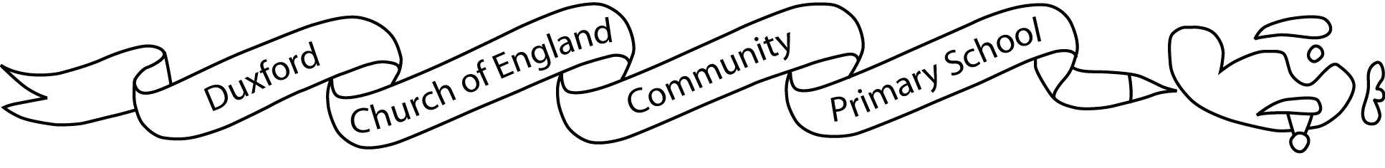

Aim High, Fly High
Dear Parents/Carers

I hope you and your family had a lovely Summer holiday. I am really looking forward to teaching this year’s Finches and getting to know them all.

Out Topic this half term is ‘The Secret Garden’ and this term’s Science topics will be about plants and the seasons ‘Information about the learning we will be doing this term can be found on the Autumn Term Topic Map. In Year 2, we have early morning learning activities before registration so it is important that your child is present and on time each morning.

This term P.E. will be on Tuesdays and Fridays. Children will still be required to attend school in PE Kit on these days. Please ensure that your child has appropriate P.E. kit (a plain white T-shirt, shorts for inside and jogging trousers, sweatshirt and suitable footwear for outside activities – plimsolls/pumps for indoor). Please also be aware that, for health and safety reasons, earrings must be removed for P.E.

Children will continue with Forest School on a Tuesday so please can you ensure that their PE has long sleeves and trousers / leggings or they bring a long sleeved top and trousers to change into (these clothes should be left at school for the half term).

Please can children bring a named bottle of water to drink during the day as well as felt tips and/or colouring pencils.

Over the next week, we will be listening to the children read and working out their appropriate reading level. Therefore, reading books will not be coming home until the week beginning 13th September. More information about reading at home will be coming soon.

The complete grid of themed home learning will be given out at the beginning of each half term (Finches will be given out on Friday, 10th September). These activities are optional and relate to our current class topic. In addition, children will be given weekly spellings (given out every Friday, starting 10th September) and multiplication tables (see themed learning grid for details) to learn and will be assessed on their progress in these each Friday. To support your child in learning these essential facts, they have access to Times Tables Rockstars (log in details will be sent home) which they should play as often as possible. Your child should read aloud at least 4 times a week to an adult at home.

If you have any questions or concerns, do not hesitate to contact me via the school office.

I look forward to working with you and your child

Kind regards
Mrs Lee Frere

