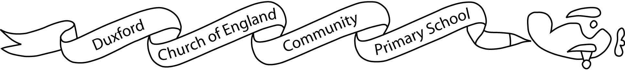
Aim High, Fly High

Dear Parents/Carers,

I hope you had a lovely summer break and welcome to Year 5! I am really looking forward to teaching the new Year 5’s this coming year and I have planned lots of exciting things to support them to make progress in their learning.

In Year 5, we start working very promptly on our start of the day activity (SODA) at 8.40am. This is an important part of my assessment of the children, so please ensure your child is on time each morning so that he/she doesn’t miss anything.

As always, we have a very busy autumn term ahead of us, starting with our Vicious Vikings and Scandinavia topics. More information on this topic can be found on the Year 5 Topic Overview. We will be studying ‘Viking Boy’ by Tony Bradman in our English lessons this half-term.

This term’s PE lessons will be on a Wednesday and Thursday. Please ensure your child comes to school in their PE kit (plain white/black/navy t-shirt, joggers or shorts, trainers and normal school jumper). Now that children will be wearing school shoes on non-PE days, having a pair of trainers in school for the daily mile would be helpful. Children are welcome to bring in a fruit or vegetable snack to eat during morning playtime. We encourage children to bring a named bottle of water to drink during the day. Children are permitted to have a small, clear pencil case this year and are encouraged to bring a small set of felt tips and colouring pencils into school.

Homework will be given out at the beginning of each half term. Each chosen piece from the optional home learning grid must be completed in their home learning book and handed in on Wednesdays.
In addition, children will be given compulsory weekly spellings, which will be tested every Thursday, and times tables to learn, which will be tested every Tuesday. To support your child in learning these essential facts and spellings, they have access to Times Tables Rockstars and Spelling Shed, both of which they should play as often as possible.
Your child should read regularly at home. Children will also be given compulsory Guided Reading home learning each week and this must be returned on Mondays via Starz.

If you have any queries, please contact the office who will pass on the message to me. I will endeavour to respond as quickly as possible.

I look forward to you working with me to help your child to have a great year.

Best wishes,
Miss Emma Hobbs

