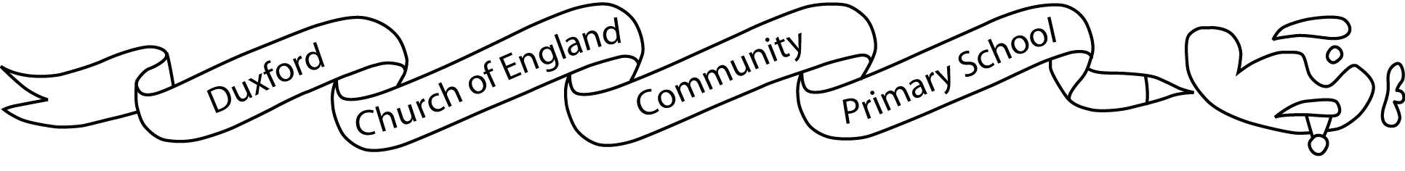

Aim High, Fly High
Dear parents/carers

We hope you have enjoyed the summer break and we are pleased to welcome your child to Year 6! We are really looking forward to the many exciting and important things that will occur this year and extremely pleased that we are now able to start to relax the Covid measures that were established last year.

As always, we have a very busy term ahead of us, starting with our topic ‘Vicious Vikings and Scandinavia,’ and this term’s science topics will be: ‘Properties and changes of materials’. Information about the learning we will be doing this term can be found on the Autumn Term Topic Map. In Year 6, we have early morning learning activities before registration so it is important that your child is present and on time each morning.

This term P.E. will be on Wednesdays. Children will still be required to attend school in PE Kit on these days. Please ensure that your child has appropriate P.E. kit (a plain white T-shirt, shorts for inside and jogging trousers, sweatshirt and suitable footwear for outside activities – plimsolls/pumps for indoor). Please also be aware that, for health and safety reasons, earrings must be removed for P.E.

Children are welcome to bring in a fruit or vegetable snack during morning playtime. We encourage children to bring a named bottle of water to drink during the day; the tap at the back of the classroom has drinking water for the children to fill bottles when they need it.

The complete grid of home learning will be given out at the beginning of each half term and your child can choose to complete one activity from the list each Friday. Each chosen piece must be completed and handed in the following Wednesday. In addition, children will be given weekly spelling tasks relating to the spelling rules we have been learning in class; they are also encouraged to use Spelling Shed throughout the week. In Year 6 we still encourage the children to use Times Tables Rockstars to practise key skills and they will be assessed on their progress in class. Your child should read regularly at home. They will be given weekly Guided Reading task, sometimes including practise SATs-style questions, which must be returned on a Monday.

If you have any questions or concerns, we may be able to meet either briefly at the end of a school day or, for a longer discussion, you will be able to make an appointment with the school office.

We look forward to working with you and your child.

With kind regards,
Miss Medley and Mrs Johnston

