Aim High, Fly High
4th September 2019
RE: History Off the Page

Dear Parents/ carers,

We are more than excited to announce that to launch our new topic- the ‘Vicious Vikings’- and as a way of providing your child with the best opportunity to find out about Life in Viking Britain, we have arranged for the amazing History Off the Page to spend the whole day with us on Monday 16th September.

On this day your child will, through role-play, experience life as it would have been living in the year 878 AD at the time of the Battle of Edington, using authentic tools and materials whenever possible to learn skills as apprentices in a wide variety of workshops. As the day progresses, the children will get involved in the issues of the time, with the chance to participate in a range of cross-curricular activities. By the end of the day they will have a really good idea of how it felt like to be a Viking. There will also be a story-telling session.

It is recommended that your child comes to school dressed in a simple Viking costume, which will help them really feel part of the day (see costume ideas on the reverse of this letter). Pupils should not include weapons as part of their costume.

In order to fund this exciting activity we ask for a contribution of £8 per pupil.

The children will be involved in a wide range of activities across the day and to support them we need a number of adult helpers, so please join us, either for the whole day, or just for the morning or the afternoon. You will see for yourself the value of the day! If you are able to help please inform your class teacher of your availability.

Yours sincerely,

Miss Medley, Mrs Johnston, Miss Hobbs (Year 5/ 6 team)

St John’s Street · Duxford · Cambridgeshire · CB22 4RA · Tel: 01223 712 108 · Fax: 01223 712 109 www.duxford.cambs.sch.uk · e-mail:office@duxford.cambs.sch.uk

Girls:
A long dress or skirt, blouse and tabard.
Headscarf
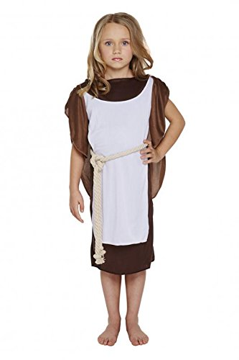
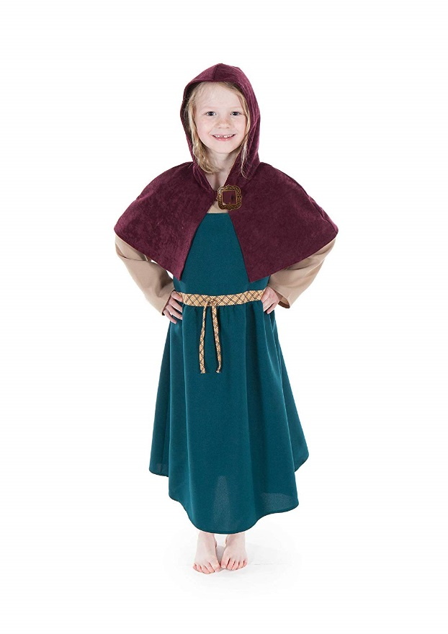
Cloak fastened with a brooch (optional).

Boys:

A simple belted tunic, with or without sleeve.
Trousers tucked into long socks.
A cloak, fastened with a brooch (optional).
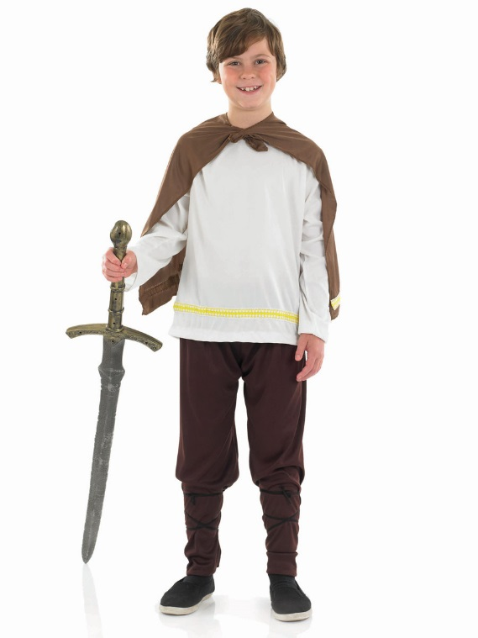

Please note: children should not bring any toy weapons

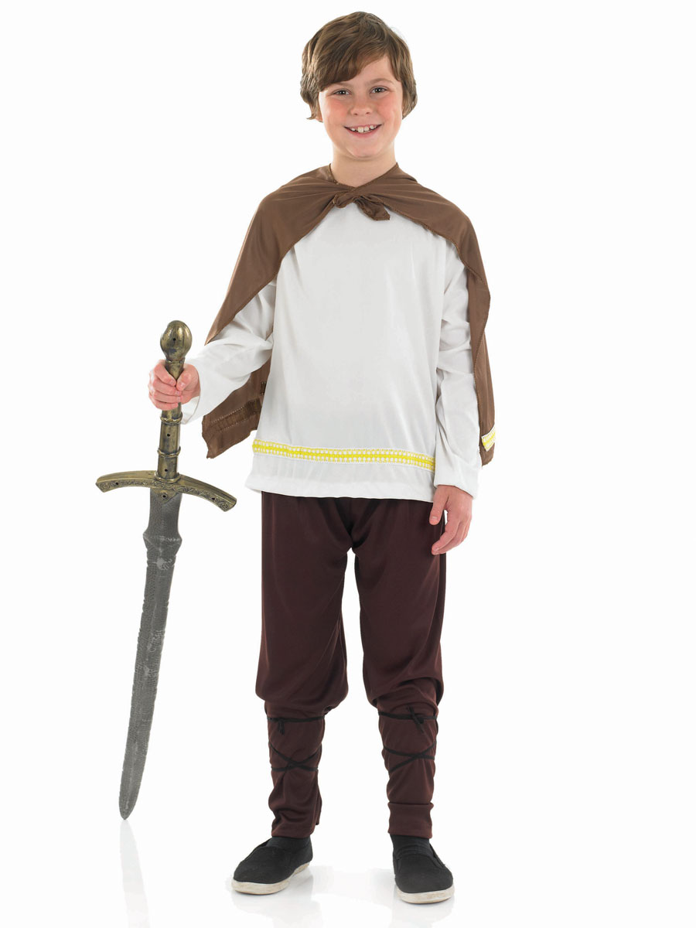 s or old leather laced shoes.

