Aim High....Fly High
11 October 2019

Dear Parents and Carers,
As part of our learning after half term, Sheldrakes class have Ark Farm coming in to visit on Friday 15th November. Ark Farm will be providing a soft, furry & friendly indoor animal experience bringing along a range of animals including Pygmy African Hedgehogs, Horsfield Tortoises and Sugar Gliders.

The experience will be carried out in small groups where the children will be introduced to each animal at an age appropriate level, told a few facts and encouraged to make some observations (noises it makes / what it’s covered in etc) and ask questions. The children are then free to move around to handle and touch the animals as they want, under close supervision.

We require written permission for your child to participate in this exciting learning opportunity and request a voluntary donation of £7.50 per child to cover the cost of the visitors. Please refer to our Charging and Remissions Policy regarding the help that might be available with the costs of the activity, particularly for children who are eligible for Pupil Premium. Please do come and talk to us in confidence if this may apply to you. We are keen that all the children take part.

Please complete the consent form with the enclosed voluntary donation to school by Friday 1st November 2019.

Kind regards

Mrs Carly Shannon
Sheldrakes Class Teacher

I do/do not give permission for…………………………………………………………………….. to
participate in the Ark Farm animal experience on Friday 15th November 2019.

I enclose a voluntary donation of £7.50 towards the cost of Ark Farm

Parent/Carer Signature………………………………………………………… Date…………………..

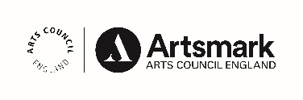 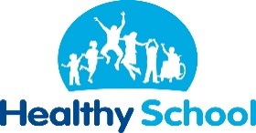 __________________________________________________________________________________________
St John’s Street · Duxford · Cambridgeshire · CB22 4RA · Tel: 01223 712 108 · www.duxford.cambs.sch.uk ·
e-mail:office@duxford.cambs.sch.uk

