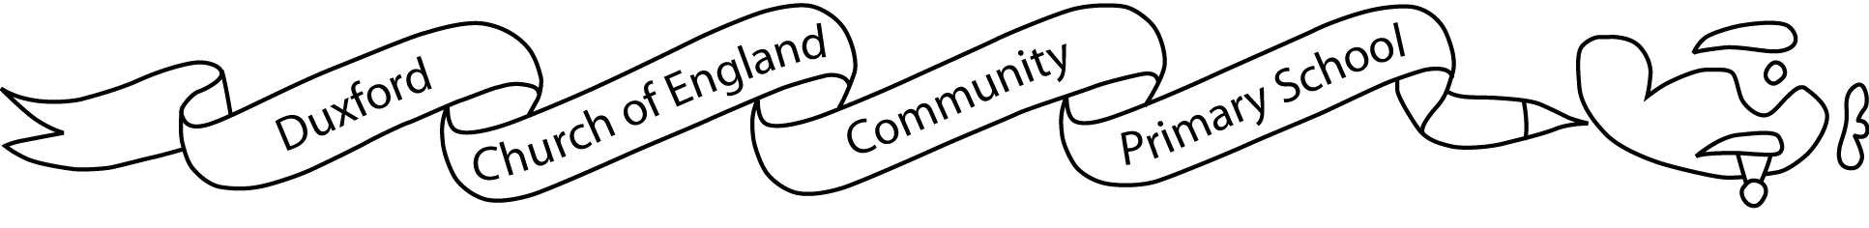

Aim High Fly High

7th January 2019

Dear parents/carers,

As part of our Spring term topic, ‘Healthy me, healthy you, healthy us’ we will be reading ‘Pig Heart Boy,’ by Malorie Blackman. The book looks at the issues of organ donation including the demand for organs and considers the ethics behind this issue as well as using animal parts in donations.

We intend to use the book to generate discussion. We understand that this is a sensitive topic and we will consider all views within our learning. We feel this book will give your child an opportunity to learn, and form their own opinions, in an unbiased manner.

If you have any concerns and would like to discuss this further, please pop in to see us.

Yours sincerely,

Miss Medley and Mrs Johnston

………………………………………………………………………………………………………………………

I have read the letter regarding the Year 6 learning around the class text ‘Pig Heart Boy.’

Signed…………………………………………………………………………………………………….