Aim High....Fly High

Dear Parents/Carers

On Wednesday 14th December Year 5 and 6 will be holding an exhibition of learning.
The children are planning a 'Viking and Scandinavia Museum' and we would like to invite parents/carers to the exhibition between 09:15 and 10:15.
The Y5 and Y6 children will tour parents around exhibitions including Viking myths and stories, Viking battles and weaponry, Longships and Longhouses, detailed maps of invasion routes and settlements, a timeline of key dates in the Viking era and their beliefs. Visitors to the museum will also be given a chance to create and translate their own runestones.

We look forward to seeing you then.
Kind regards

Miss Medley, Mrs Johnson and Mr Lloyd

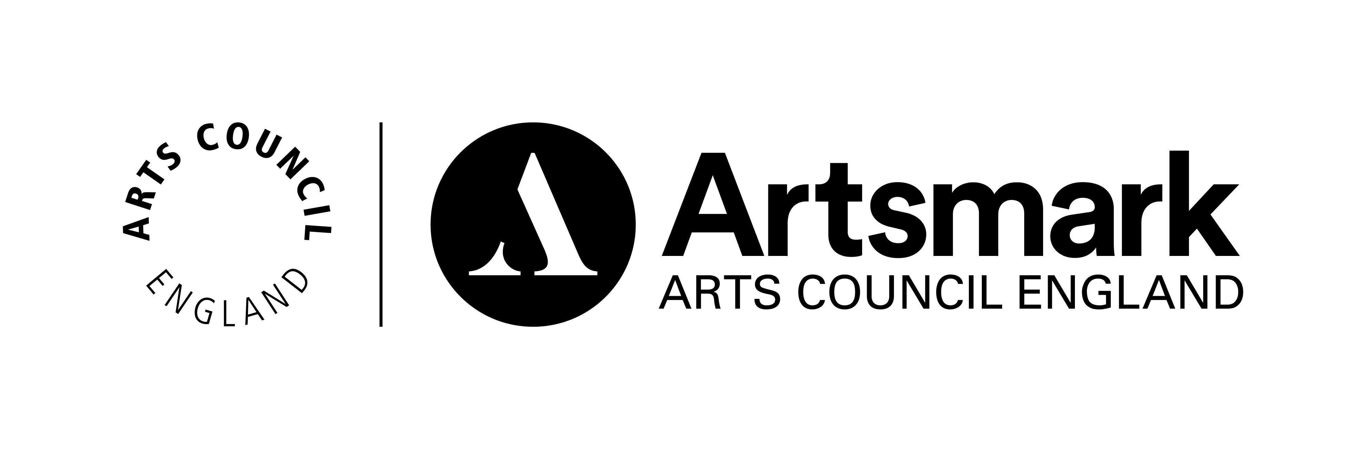 ____________________________________________________________________________

St John’s Street · Duxford · Cambridgeshire · CB22 4RA · Tel: 01223 712 108 · Fax: 01223 712 109 www.duxford.cambs.sch.uk · e-mail:office@duxford.cambs.sch.uk

