.,,.

,I'

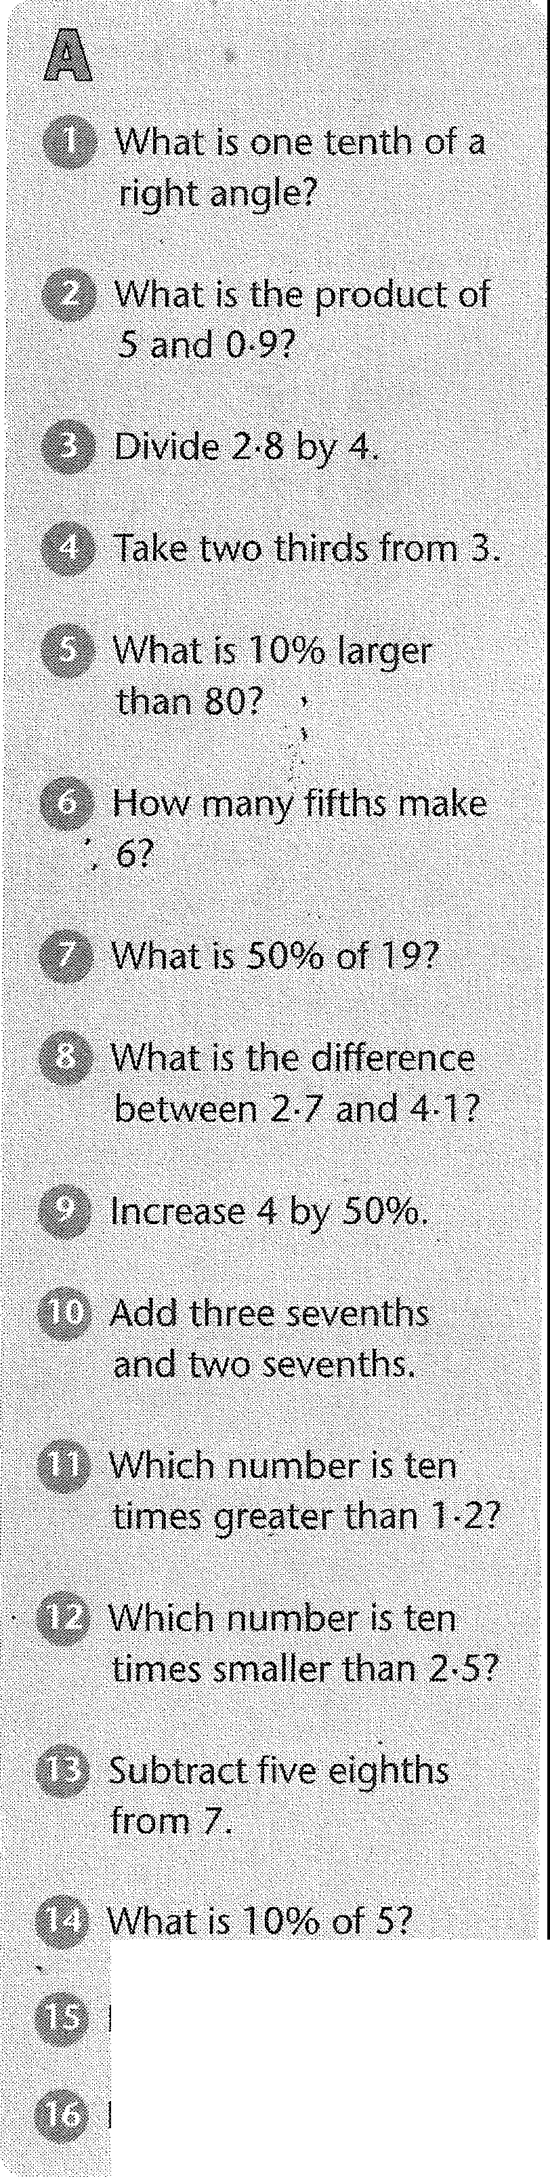
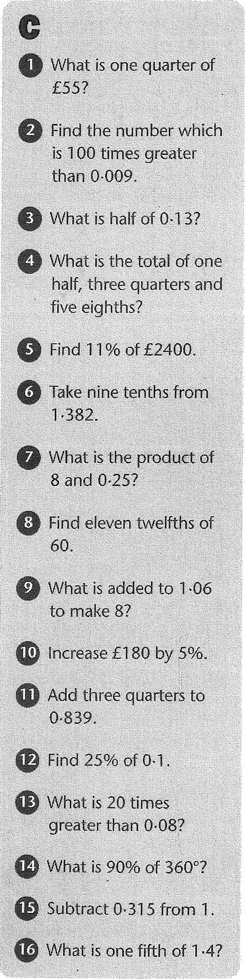

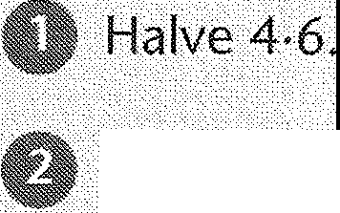
What is three tenths
plus one and a half?

How much is £5
increased by 50%?

Find the difference between 1.5 and 0,15.

Find one quarter of
180°.

What needs to be addedto 1-36 to make2?

How many eighths are
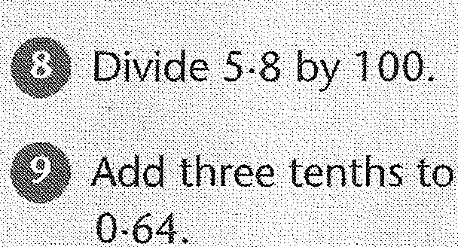
there in two and a half?
,,
What is 1% of £50? Multiply 0•77 by 100. Find •Seven ninths of 27.
What is seven tenths
minus one quarter?

What is the cost·of a
£19<jumper if the price
is reduced by 10%? What is twice 0•8? Find90% of £35

