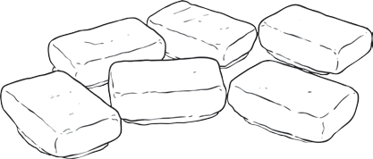

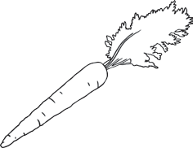



Multiplication and Division Word
Problems x6 x7 x9
1. There are 8 chocolates in a bag, and Josef has 6 bags to sell. How many chocolates are there in total?

2. Sarah gets £4 pocket money from her parents every day of the week if she does all of her chores. How much pocket money would she get in a week?

3. The farmer plants carrots in rows of 9. He decides to plant 7 rows of carrots. How many
carrots are there in total?

4. Mary downloaded the same number of apps for her phone each week. She downloaded 54 apps over a period of 9 weeks. How many apps did she download each week?

5. Joe plants 5 bushes in his garden. Each bush blooms 6 flowers. How many flowers are there in total?

6. If I save £21 in one week (saving an equal amount each day), how much money do I save each day?

7. Francis is very good at hurdles. She can jump 9 hurdles in a 200 metre race. However,
Johnathon can jump
twice as many. How many hurdles can he jump?

8. It takes 24 minutes for Jessica to ride her bike to school. On the way, she stops at regular intervals to retie her shoelaces. She stops 4 times on her trip. How many minutes were between each stop?

9. My teacher decided to reward us with a pizza party at the end of the week. There are 21 people in my class, and each person is allowed 2 pieces of pizza. A pizza has 7 slices. How many pizzas does he need to buy?

visit twinkl.com.au

