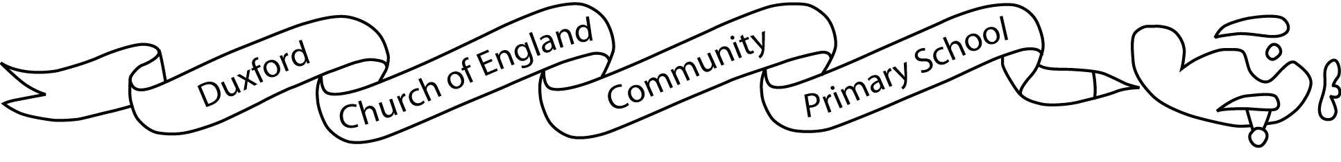
Airwaves 20th March 2020
No. 26

Dear Parents and Carers

Amount of work – structured day – on website
Starz – to stay in touch with friends – no unnecessary gatherings (Boris bit) monitored – sensible use or stops
PP school meals
In school this week…

KS2 Production
Blackbirds, Wrens and Hawks performed their production ‘Let the Games Begin’ to the rest of school on Thursday. It was a fantastic performance with some really great singing and acting. The link has been emailed out to parents of those children. We hope you enjoy it as much as we did!

Mothers’ Day Posies
We hope you enjoyed receiving your Mothers’ Day posies. The children really enjoyed making them.

Suzanne Blackburne-Maze
Headteacher

Diary Dates
Wednesday 1 April |  | Spring term closes
Thursday 2 and Friday 3 April |  | Training Days
Monday 20 April |  | Summer term starts
Friday 8th May |  | May Day
Monday 25 to Friday 29 May |  | Half-term
Tuesday 21 July |  | Summer term closes
Thursday 3 and Friday 4 September 2020 |  | Training Days
Monday 7 September |  | Autumn term starts
Monday 26 to Friday 30 October |  | Half-term
Friday 18 December |  | Autumn term closes
Monday 4 January 2021 |  | Training Day
Tuesday 5 January |  | Spring term starts
Monday 15 to Friday 19 February |  | Half term
Friday 26 March |  | Spring term closes
Monday 12 April |  | Training Day
Tuesday 13 April |  | Summer term starts
Monday 31 May to Friday 4 June |  | Half-term
Monday 7 June |  | Training Day
Friday 23 July |  | Summer term closes

